**Day 21**

Speech-language therapy can help children with Down syndrome improve their communication skills and use language more effectively.  
a. Children with Down syndrome often learn to speak later than their peers. A speech-language therapist can help them develop the early skills necessary for communication, such as imitating sounds. The therapist also may help an infant breastfeed because breastfeeding can strengthen muscles that are used for speech.5  
b. In many cases, children with Down syndrome understand language and want to communicate before they can speak. A speech-language therapist can help a child use alternate means of communication, such as sign language and pictures, until he or she learns to speak.7  
c. Learning to communicate is an ongoing process, so a person with Down syndrome also may benefit from speech and language therapy in school as well as later in life. The therapist may help with conversation skills, pronunciation skills, understanding what is read (called comprehension), and learning and remembering words.



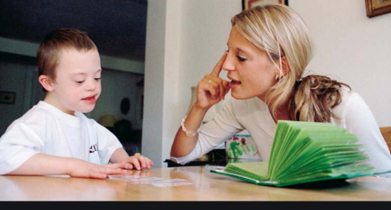

**Day 22**

Occupational therapy helps find ways to adjust everyday tasks and conditions to match a person's needs and abilities.  
a. This type of therapy teaches self-care skills5 such as eating, getting dressed, writing, and using a computer.  
b. An occupational therapist might offer special tools that can help improve everyday functioning, such as a pencil that is easier to grip.  
c. At the high school level, an occupational therapist could help teenagers identify jobs, careers, or skills that match their interests and strengths.



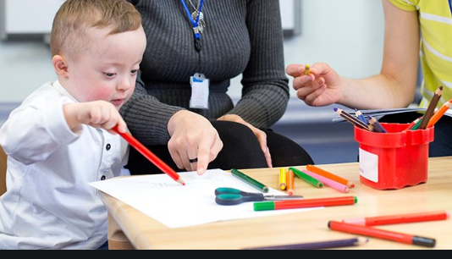

**Day 23**

30. Emotional and behavioral therapies work to find useful responses to both desirable and undesirable behaviors. Children with Down syndrome may become frustrated because of difficulty communicating, may develop compulsive behaviors, and may have Attention Deficit Hyperactivity Disorder and other mental health issues. These types of therapists try to understand why a child is acting out, create ways and strategies for avoiding or preventing these situations from occurring, and teach better or more positive ways to respond to situations.  
a. A psychologist, counselor, or other mental health professional can help a child deal with emotions and build coping and interpersonal skills.  
b. The changes in hormone levels that adolescents experience during puberty can cause them to become more aggressive. Behavioral therapists can help teenagers recognize their intense emotions and teach them healthy ways to reach a feeling of calmness.  
c. Parents may also benefit from guidance on how to help a child with Down syndrome manage day-to-day challenges and reach his or her full potential.





**Day 24**

Contrary to popular belief, people with Down syndrome are not always happy. They experience every emotion you and I do. They experience the full range of emotions. They respond to positive expressions of friendship and are hurt and upset by inconsiderate behavior.







**Day 25**

Siblings of kids with Down syndrome are not affected negatively, on the contrary, most siblings report their relationship with a brother or sister with Down syndrome is one of the greatest gifts in their lives. Studies show that 99% of adults with Down syndrome are happy with their lives and only 5% of parents feel embarrassed by their child with Down syndrome.

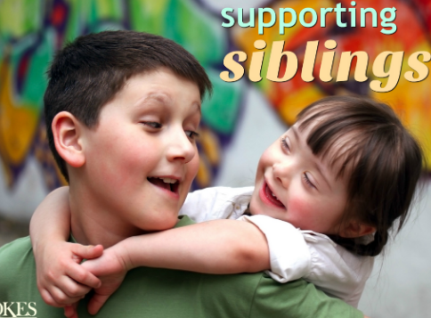



**Day 26**

Adults with Down syndrome are not children, and should not be considered children. They enjoy activities and companionship with other adults, and have similar needs and feelings as their typical peers. They socialize and have meaningful friendships. Some choose to date, maintain ongoing relationships and marry.

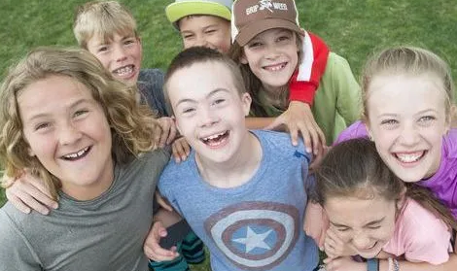

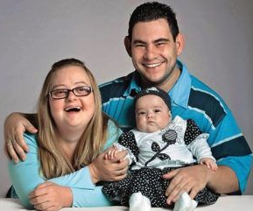



**Day 27**

Fifty years ago, parents were encouraged to send their babies born with Down syndrome to mental institutions. That was not too long ago. What you see now is the hard work and determination of parents (like Rekha Maa) willing to fight the battle for their children, and for the many that have followed.

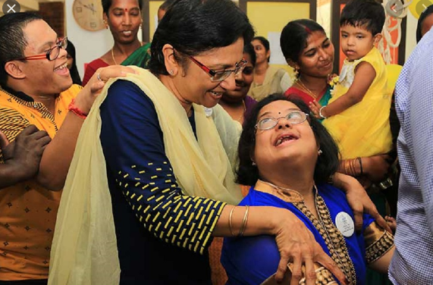

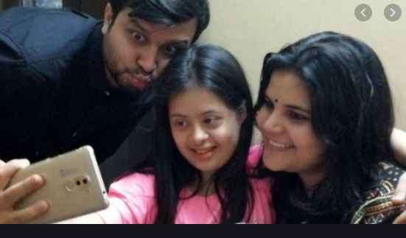



**Day 28**

You will get what you expect! Just because a child has Down syndrome it does not mean they are unable to be well behaved or follow directions. Kids with Down syndrome are smart, it takes them a few minutes to recognize expectations, and you will be manipulated to the best of their ability. Businesses employ adults with Down syndrome for a variety of positions – in banks, corporations, hotels, hospitals, nursing homes, offices and restaurants. They work in the music and entertainment industry, in clerical positions, childcare, the sports field and the computer industry, to name a few. Like anybody else, people with Down syndrome want to have a job where their work will be valued.



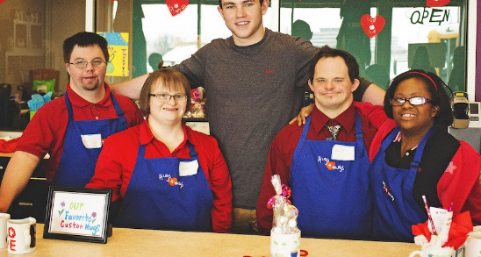

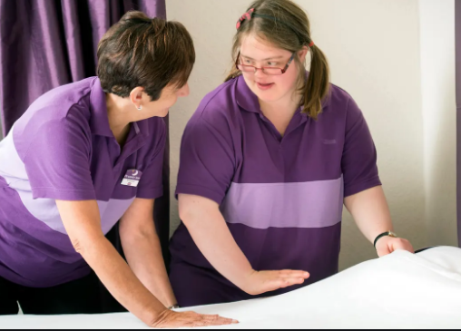

**Day 29**

It is a myth that behavior problems and depression are just part of having Down syndrome. However, the fact is that often, medical or mental health problems go untreated due to the assumption that it is typical of this genetic condition. Complete examinations by appropriate health care professionals should always be pursued.

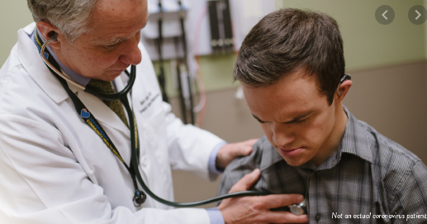

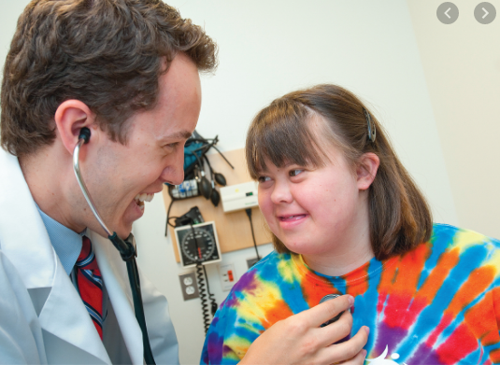

**Day 30**

It is a myth that individuals with Down syndrome are stubborn. The fact is that the individuals with Down syndrome may not be able to tell you how she/he feels. This can lead to the false perception that they are “stubborn.” Behavior is communication. Consider all of the circumstances.

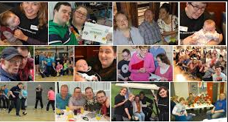

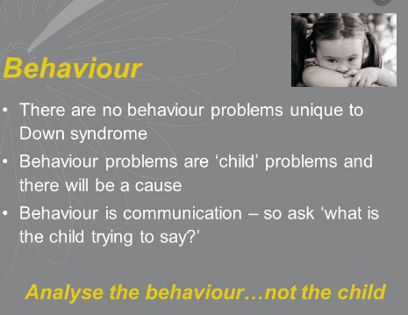

**Day 31**

A recent study published in Scientific Reports, and publicized by the Global Down Syndrome Foundation, changed the perception of Down syndrome as a brain disorder and categorized it as immune system dysfunction instead. According to the study, intellectual disability related to Down syndrome may be the result of a hyperactive immune system.  
Research on Down syndrome is making great strides in identifying the genes on chromosome 21 that cause the characteristics of Down syndrome. Scientists now feel strongly that it will be possible to improve, correct or prevent many of the problems associated with Down syndrome in the future.



